### Lab 3: RAG application using Amazon OpenSearch

1. Complete the pre-requisites for the lab
   1. Delete both the endpoints created in the previous labs

Note: the name of the end point will be different in your case

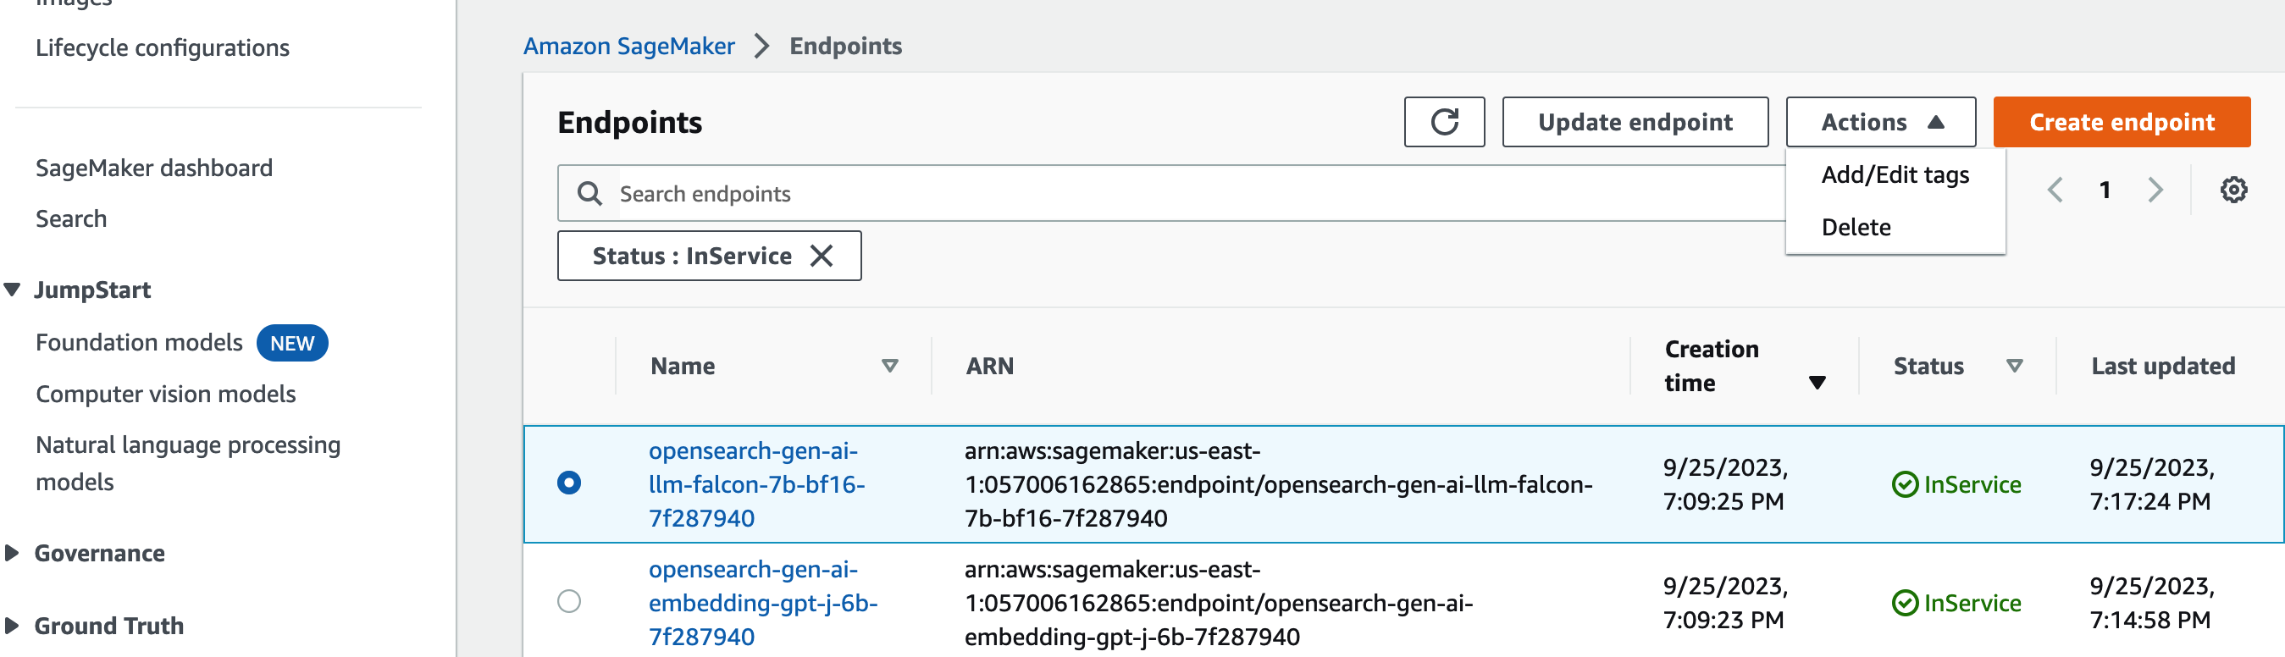

* 1. Download the dataset required for running the lab. The dataset is available in <https://github.com/thandavm/rag_sm_js/blob/main/data/winemag-data-130k-v2.json>

1. Launch the Cloud formation stack from <https://catalog.workshops.aws/semantic-search/en-US/setup/using-own-account>

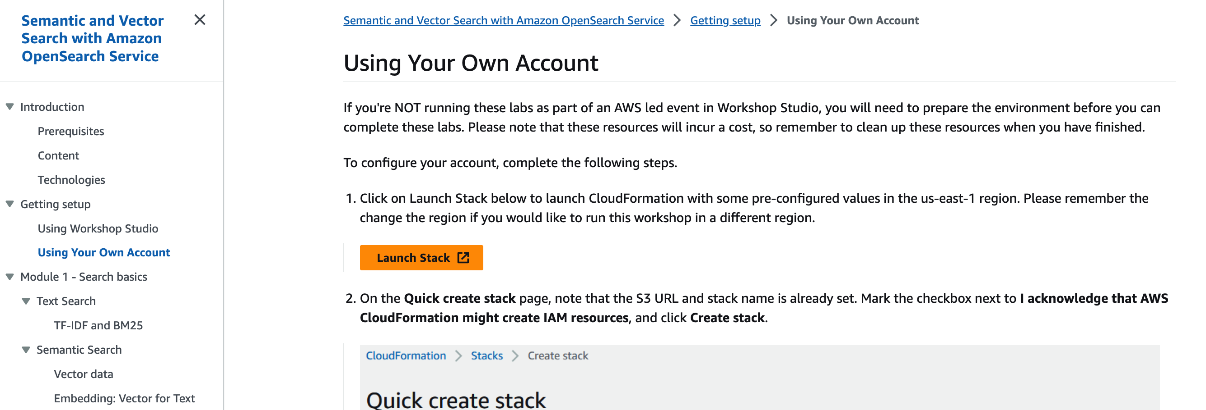

1. Select “I Acknowledge….” And click on “Create Stack”. The stack creation takes ~15 mins to complete

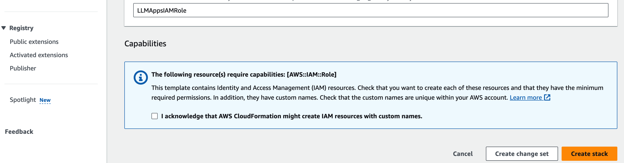

1. Once the stack is created. Go to SageMaker -> Notebook Instances.

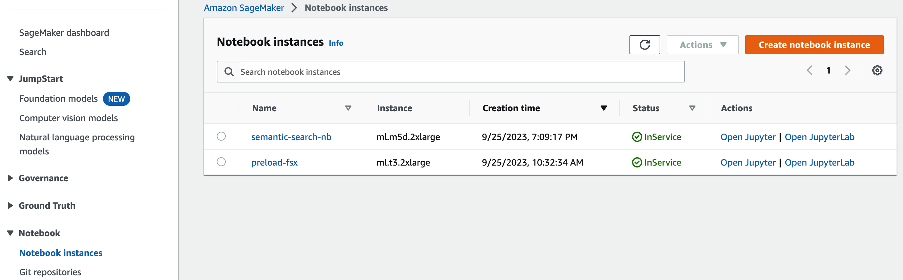

1. Open “[semantic-search-nb](https://us-east-1.console.aws.amazon.com/sagemaker/home?region=us-east-1#/notebook-instances/semantic-search-nb)” and launch “Open Jupyter”

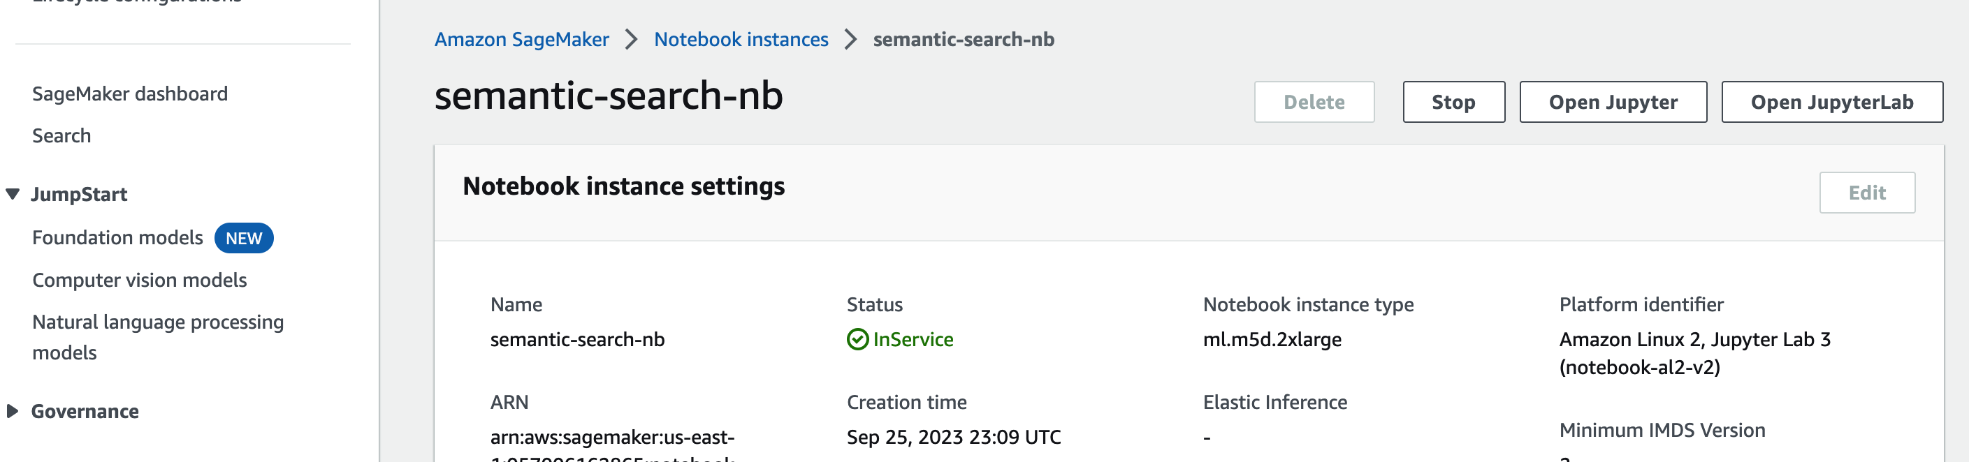

1. Click on “Upload” and load the downloaded “[winemag-data-130k-v2.json](https://semantic-search-nb-gkmp.notebook.us-east-1.sagemaker.aws/edit/semantic-search-with-amazon-opensearch/winemag-data-130k-v2.json)”

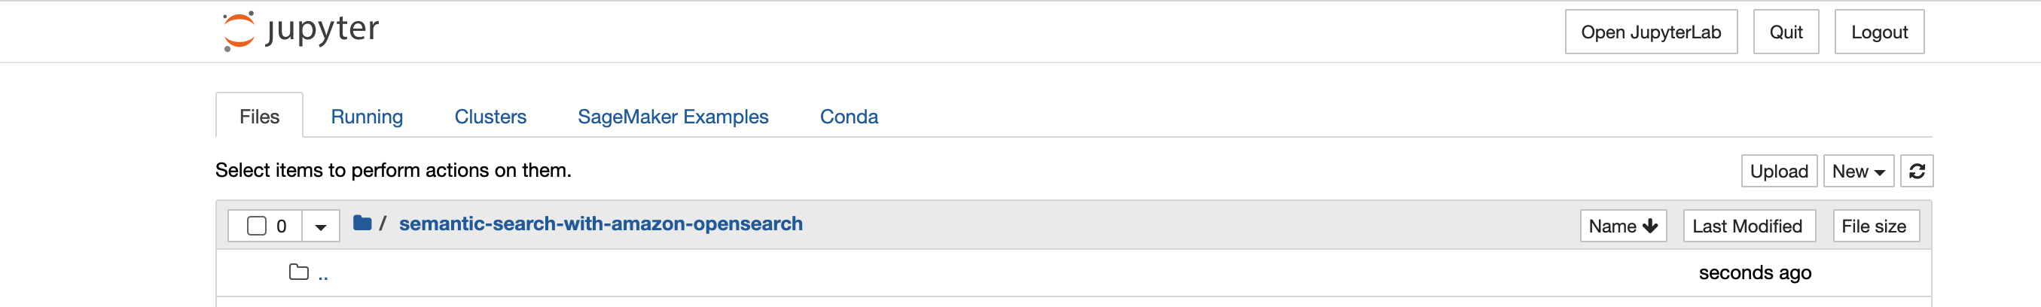

1. Open the Notebook “[Module 7 - Retrieval Augmented Generation.ipynb](https://semantic-search-nb-gkmp.notebook.us-east-1.sagemaker.aws/notebooks/semantic-search-with-amazon-opensearch/Module%207%20-%20Retrieval%20Augmented%20Generation.ipynb)” and add the endpoints created as part of the cloud formation template. Search for the cell below and add the SM falcon end point name here

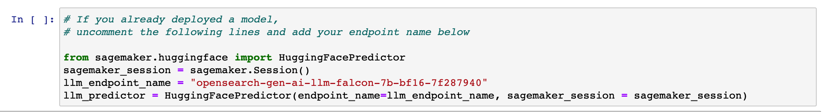

1. Start executing the Notebook
2. Do not execute Step 12, because we have already deployed the model

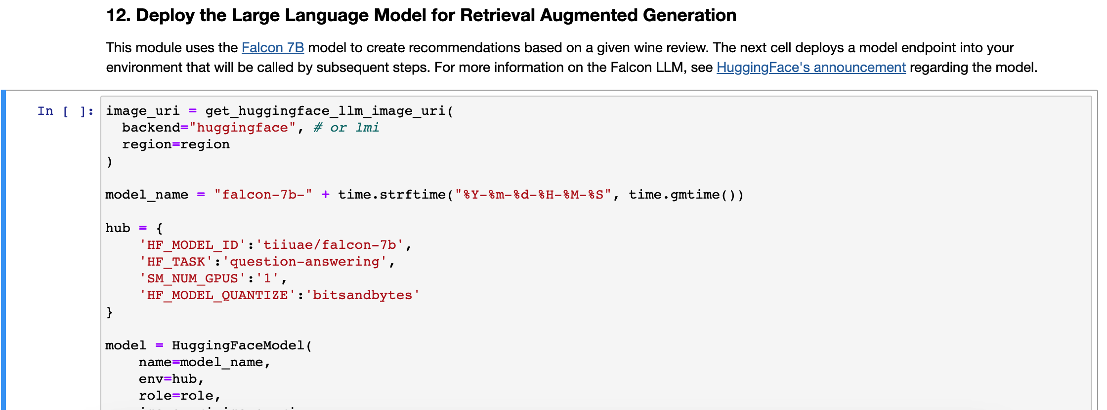

1. Continue and complete the lab!!!